NAME: Saraf Abhinav

ROLL.NO: 2420090058

SEC: 2

**Computer Networks - 24CS2202**

**Experiment: 6–** Configuration of Network address translation in Cisco packet tracer and verify the configuration

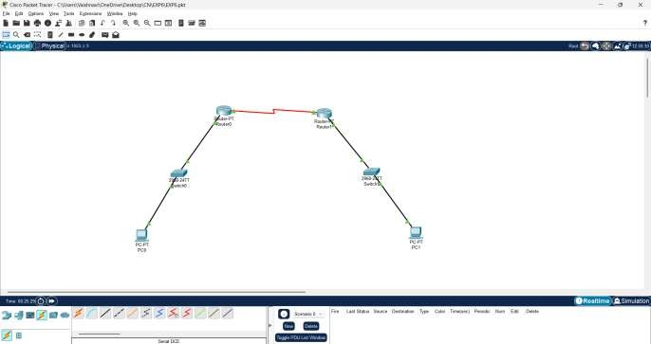

**Network Topology**

* **Left LAN:**
* PC0: 10.10.10.2/24, Gateway = 10.10.10.1
* Router-0 Fa0/0 = 10.10.10.1 • Router-0 Serial2/0 = 192.162.10.1
* **Right LAN:**
* PC1: 20.20.20.2/24, Gateway = 20.20.20.1
* Router-1 Fa0/0 = 20.20.20.1 • Router-1 Serial2/0 = 192.162.10.2
* **Public IP Mapping:**
* PC0 (10.10.10.2) ↔ 50.50.50.2
* PC1 (20.20.20.2) ↔ 60.60.60.2

**Configuration Steps Step 1: Configure IP on PCs**

* **PC0:**
* **IP:** 10.10.10.2
* **Subnet:** 255.255.255.0
* **Gateway:** 10.10.10.1
* **PC1:**
* **IP:** 20.20.20.2
* **Subnet:** 255.255.255.0
* **Gateway:** 20.20.20.1

**Configure Router-0 & Verify NAT Configuration**

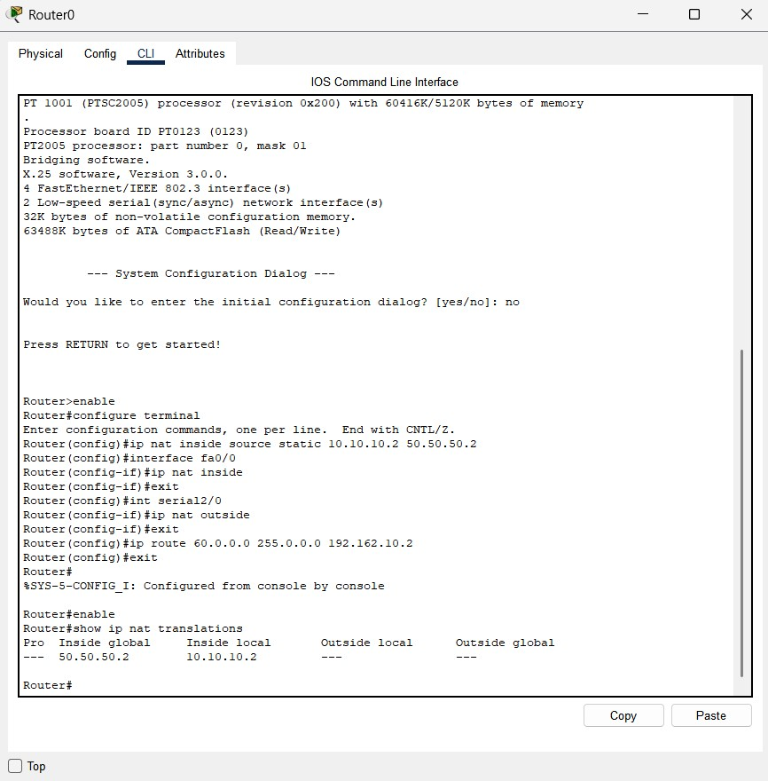

**Configure Router-1 & Verify NAT Configuration**

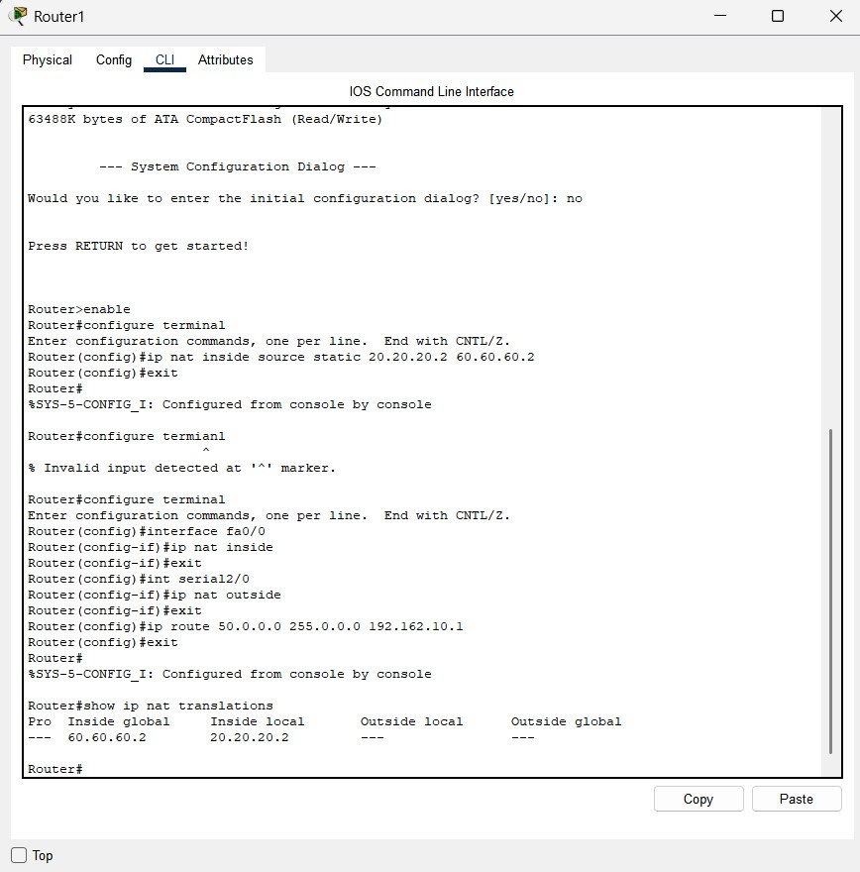

**Output :-**

